Function Plotting, Salting, and Smoothing using Jfreechart and Apache

Overview
This Java-based project demonstrates a simple data visualization and signal processing pipeline. It consists of three main stages:
- Function Generation – Computes values for the function y = x² + x over a specified range.
- Data Salting – Adds random noise (salt) to the function values to simulate real-world signal corruption.
- Data Smoothing – Applies a moving average algorithm to reduce noise and reveal the underlying trend.
The project uses the JFreeChart library for plotting and Apache Commons Math for statistical smoothing.

Components

1. FunctionPlotter
Purpose:
Generates the original dataset by evaluating the function y = x² + x for integer values of x from 0 to 1000.
Key Features:
- Stores the generated (x, y) pairs in an XYSeries object.
- Plots the data using a line chart.
- Displays the chart in a window titled "Function Plotter".

2. SaltData
Purpose:
Introduces randomness into the original dataset to simulate noisy or corrupted data.
Key Features:
- Random values in the range of -100,000 to +100,000 are added to each y-value.
- The x-values remain unchanged to preserve alignment.
- The salted data is stored in a new XYSeries.
- A new chart window titled "Salting" visualizes the noisy data.

3. SmoothData
Purpose:
Cleans up the noisy (salted) dataset using a moving average approach.
Key Features:
- For each data point, the algorithm calculates the mean of its surrounding y-values within a window of size 50 (both before and after).
- Uses DescriptiveStatistics from Apache Commons Math to calculate the mean.
- Plots the smoothed values in a new chart titled "Smoothing".

4. PlotTester (Main Class)
Purpose:
Controls the execution of all three stages in order.
Workflow:
- Generates and plots the original function data.
- Applies salting to add noise and plots the result.
- Applies smoothing to the salted data and visualizes the cleaned result.

Technologies Used
- Java (JDK 17+)
- JFreeChart – For data visualization.
- Apache Commons Math – For statistical operations.
- Swing (JFrame, JPanel) – For GUI window management.

How It Works
- The user runs PlotTester.java.
- Three sequential windows appear:
  - A plot of the original y = x² + x curve.
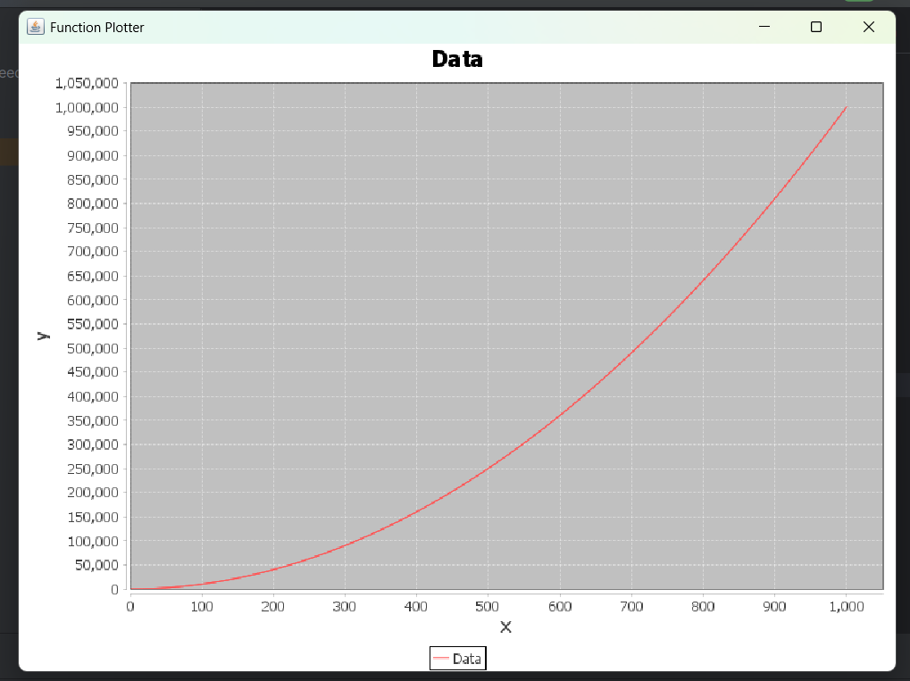
  - A plot of the same data with random noise added.
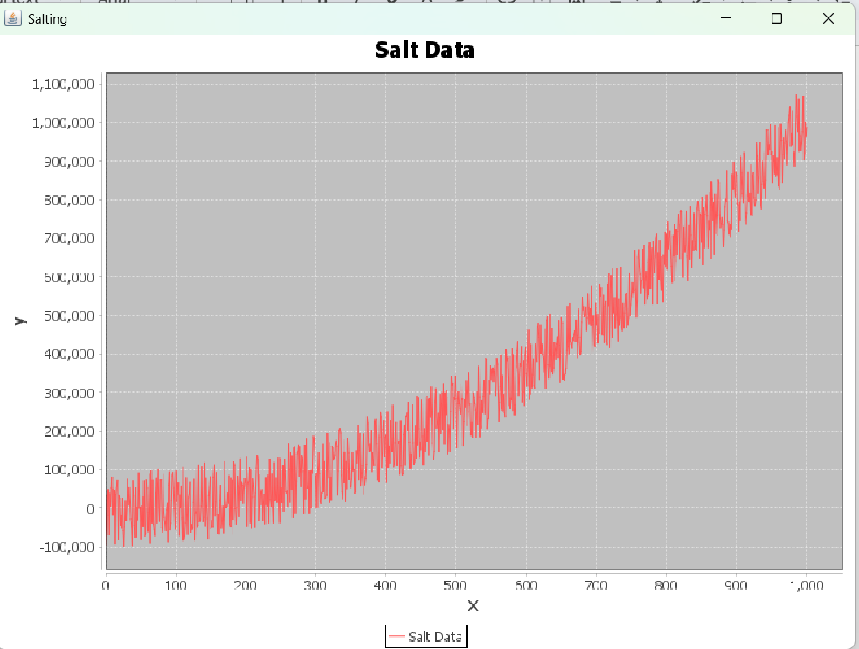
  - A smoothed version of the noisy data using mean filtering.
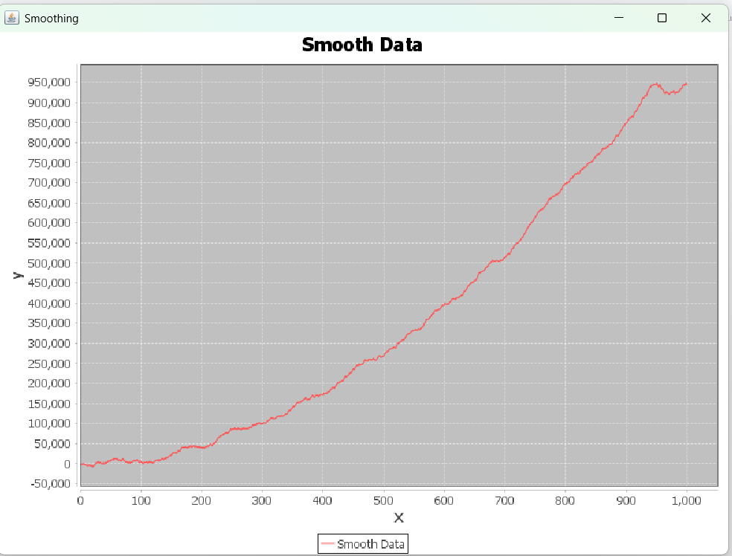
This flow mimics real-world data processing where ideal values are first distorted by noise and then restored using smoothing techniques.

